This project is not divided into lessons, but I thought it might be better to note them if I divided them into lessons.

**Lesson 1:**

We basically took the names from the last project sheet and created these new columns for *Safety Test*, *Company Philosophy Test*, *Financial Skill Test*, and *Drug Test.* The total points of these tests are set to be 10, 20, 100 and 1 respectively. The instructor filled in manual numbers but I thought its too cumbersome and so I used =RANDBETWEEN function to generate the numbers. The instructor then proceeded to use ***Condition Formatting*** on these columns. He used one with four shapes as to divide the numbers into quartiles.

***Conditional Formatting*** works on the selection and does not depend on column. Here I selected two of these columns to add ***Conditional Formatting***naively thinking it will automatically separate the formatting based on columns, and this is the result. The *Company Philosophy Test* got placed in all Q4s because the quartiles have been drawn from the maximum value of the selection, 100.

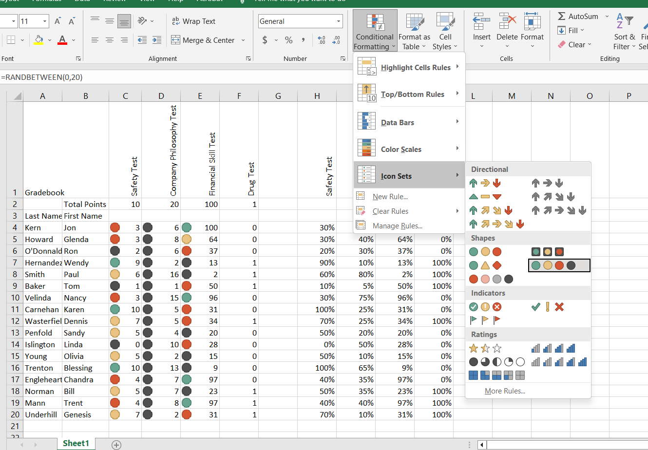

I explored the rest of them and it is basically similar. They consider the maximum value of the selection as reference and based on the type we chose it marks them. The screenshot here is taken from the *Main* page of the Excel file.

**Lesson 2:**

Now the instructor found out the percentages of the tests by applying formula. The main takeaway is the absolute referencing can be placed before the cell number as well. In the 1st project we used absolute referencing on the column something like *$C4.* But here in this project we needed absolute cell referencing and we used something like *C$4*. So, depending on the position of the dollar sign, the absolute reference changes.

Additionally, it is enough to express the percentages as ratio and there is no need to separately multiply them by 100 because, the ***Percentage Number Formatting*** automatically multiplies the ratio by 100.

Next the instructor ***Conditionally Formatted*** the percentages using ***Highlight Cell Rules*** and marked all the scores below 50%. But since I used the =RANDBETWEEN function to generate these numbers, below 50% gave me too many red cells. So, I tempered it down to 20%. And I separately ruled the *Drug Test* score to be a 100%, i.e., mark red below 100%. It was clearly unnecessary but I just felt like doing it accurately.

Finally, a *Problematic?* column was created where =OR was used to see if an employee passed the minimum required marks or not. You basically needed to pass in all sections individually to gain an overall pass; else you get flagged as problematic.

Like the previous project, the max, min and average were also calculated. Because the ***Conditional Formatting*** has been used on the numbers, it was creating some unwanted issues in the max, min and average section and the formatting had to be cleared from these cells through manual selection.

**Lesson 3:**

This part basically covered plotting. Excel treats every graph as an array/series vs another array/series. So as long as the arrays/series are equal in length, you can plot anything, given one of them is actually plottable. The other is called the reference array/series. Data can be changed anytime from ***Select Data*** option by right clicking the chart or graph.

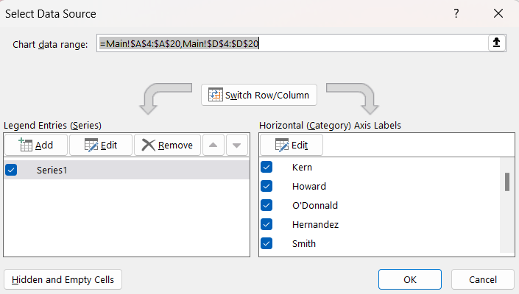

Here the horizontal axis doesn’t seem like an array or series, does it? No because it adds extra functionality on top of the array. Here I can select or deselect any specific reference directly from this prompt and the graph will update itself. If a certain reference is deselected, it (along with its corresponding value) won’t appear in the graph. Might be a bit confusing coming from more rudimentary programming languages as we never got anything like click and modify in those languages.